**Q. Write a map reduce program to join the below given two datasets using Reducer side join.**

**Driver:-**

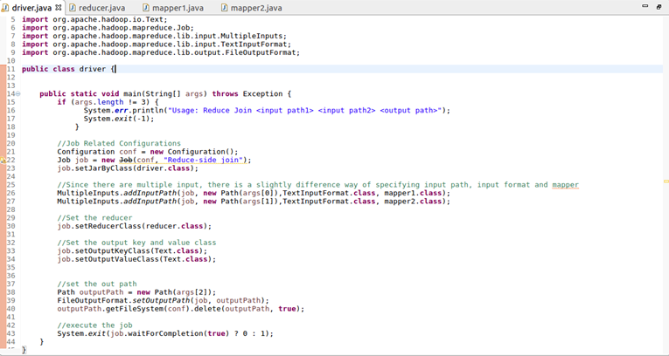

**Mapper 1:-**

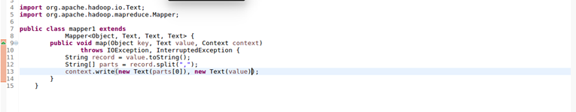

**Mapper 2:-**

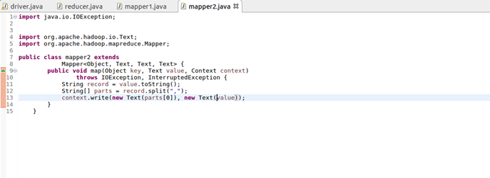

**Reducer:-**

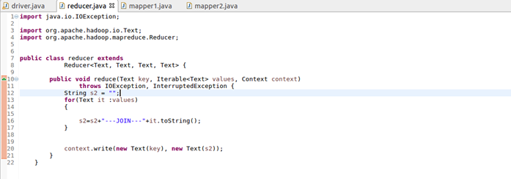

**Output:-**

